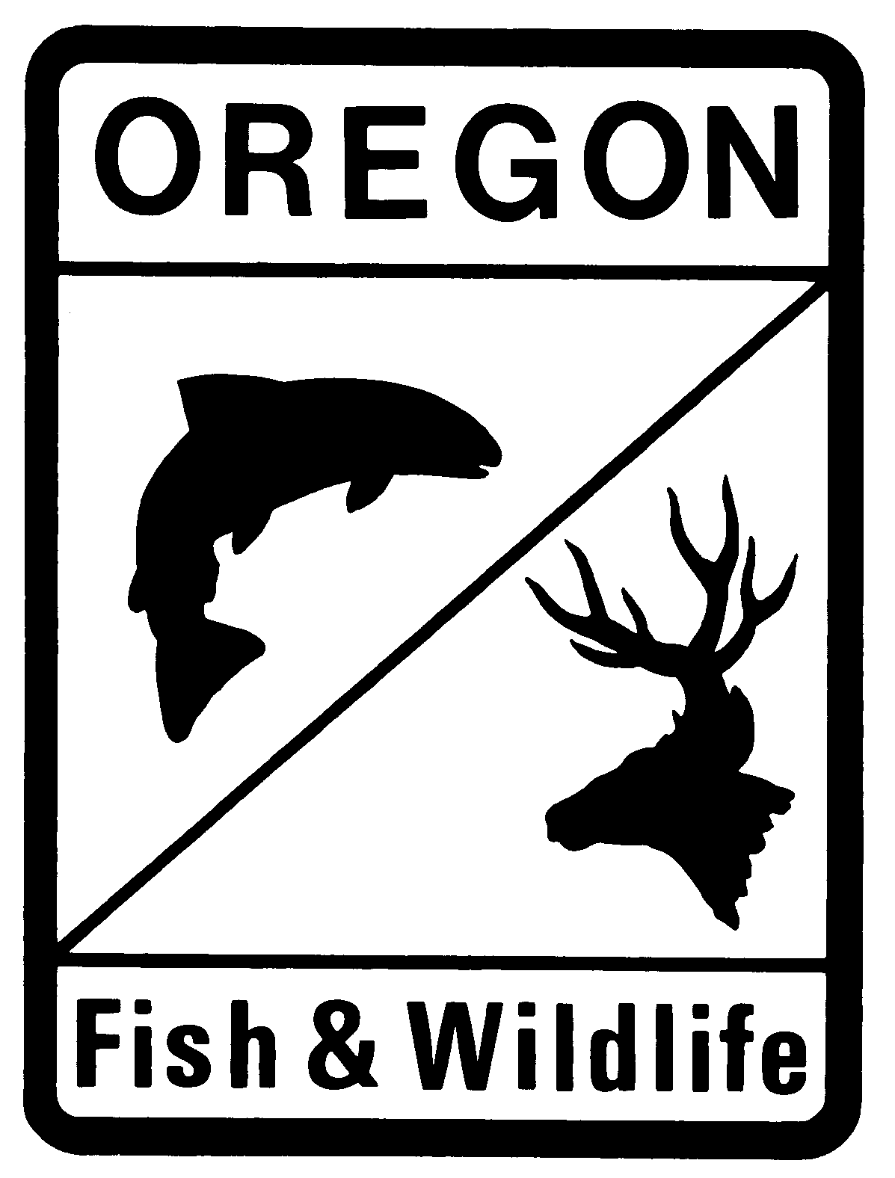
Oregon Department of Fish and Wildlife
Fish Passage Plan for Beaver Dam Analogue and Post Assist Log Structures
--- Standard Plan Application ---

Project Name:
Project Purpose:
Date of Fish Passage Submittal:
Date of Proposed Construction:

Applicant Information

Property Owner: Title:
Organization:
Address:
City: State: Zip:
E-Mail Address:

Signature: __________________________________________________ Date: _____________

Project Sponsor: Title:
Organization:
Address:
City: State: Zip:
E-Mail Address:

Signature: __________________________________________________ Date: _____________

Authorized Agent: Title:
Organization:
Address:
City: State: Zip:
E-Mail Address:

Signature: __________________________________________________ Date: _____________

Project Location

County:
Road Name:
River/Stream:
Tributary Of:
Basin:
Coordinates (NAD 83 in decimal degrees to at least 4 places):
Latitude: °N
Longitude: °W
Project Name:
Project Information
Please fill in below, or attach a proposal containing the following information. Clarification and definitions are shown in the footnotes. Please feel free to unlock the form or attach additional sheets as necessary.

Purpose, need and goals of the project
Describe the treatment reach and intent of the beaver dam analogues (i.e. beaver recruitment, channel bed aggradation, floodplain connectivity, grade control, streamflow duration, water table elevation, etc.).

Project Reach
Include the average for the project reach.
Project reach length
Streambed slope (%)
Active channel width
Active channel height
Low terrace height
High terrace height
Floodplain width

Are beaver currently present at the project location? Yes No

Scope and Design of the Project
Narrative description of the overall plan, including the number of structures, how they are expected to function together, diameter of the posts and horizontal spacing, height and density of the weaved materials, other materials that will be utilized, and source of materials (on/off site). Fill in the table with existing conditions for each structure, beginning at the downstream end of the project. Please specify measurement units (ft/m).

Structure Identifier | Distance upstream to next structure | Streambed slope upstream to next structure (%) | Active Channel Width | Active Channel Height | Floodplain (high terrace) width | Dam Crest Height | Number of posts | Description of how this structure is designed to function.

Construction Techniques
Include method of installation, equipment that will be used and site access.

Water Management and Fish Exclusion Plan
What are the anticipated flows during construction? If stream de-watering is proposed, include a description of the methods that will be used to de-water and exclude fish from the work area. Fish salvage must be performed by a qualified person in possession of a valid Oregon Scientific Take Permit.

Monitoring, Reporting, and Maintenance
Monitoring and reporting on the effectiveness of fish passage through this project will be required. Monitoring reports shall be completed by a qualified biologist or natural resources technician, and submitted to the ODFW Fish Passage Program by December 31 annually for a period of 3 years after completion of the project. The site shall be visited two times after the first winter during high and low stream flows, and one time annually for the following two years. Monitoring shall include visual observations, photos of representative structures, and a summary of how each structure is performing with regards to fish passage. If monitoring indicates that fish passage is not being adequately provided, unless a beaver has assumed maintenance of the structure, the landowner is responsible for coordinating with ODFW and correcting any fish passage deficiencies.

Attachments
Please attach the following design drawings, maps or photos with the specified information on them.
-- Plan view or aerial Photo showing
- Location of proposed structures
- Location of treatment reaches
- Location of stream channel cross sections
- Active Channel width (ACW)
- Extent of current floodplain

-- Cross-Sections of Stream Channel and Floodplain
- One representing each reach type (configuration of ACW, low and high terraces)
- Shape of stream channel and floodplain
- Active Channel width and height
- Low/high terrace widths and heights

-- Cross-Section of Proposed BDA Structures
- Active Channel elevation
- Low/high terraces with average height (from channel thalweg)
- Spacing of posts
- BDA dam crest height

-- Photos of
- Site
- Stream channel and banks
- Representative proposed BDA locations

Email complete application and requested attachments and materials to the ODFW Fish Passage Coordinators Greg.D.Apke@ODFW.Oregon.gov. Allow up to 60 days for application processing. State fish passage authorization for project is dependent on compliance with fish passage design criteria.

For additional information and assistance please contact Greg Apke, ODFW Statewide Fish Passage Program Coordinator at 503-947-6228. You can also contact the local ODFW District Fish Biologist or visit the ODFW Fish Passage Web Site (see below links).
ODFW Local Contacts
ODFW Fish Passage Requirements

Please allow at least 60 days for processing prior to proposed construction.
The property owner is ultimately responsible to ensure that the structures maintain fish passage over time. This party will monitor and maintain this project and is responsible for remedying the situation should the project become a fish passage barrier in the future. The approval will be issued to both the property owner and the project sponsor.
If different than above.
Active channel width is the stream width between the ordinary high water lines, or at the channel bankfull elevation if the ordinary high water lines are indeterminate.
Measure active channel height, terrace height and dam crest height from the thalweg (lowest point) in the stream channel.
Low terrace is located below the active channel height, which represents the accessible floodplain height.
High terrace is located above the active channel height, which represents the confining floodplain.
Floodplain width is the distance between the banks of the high terrace, if present. Otherwise, use valley width.
Gap between the posts.
Dam crest height is the distance from the thalweg to the lowest elevation water would spill over the top of the dam.

